Team Milestone Week 6

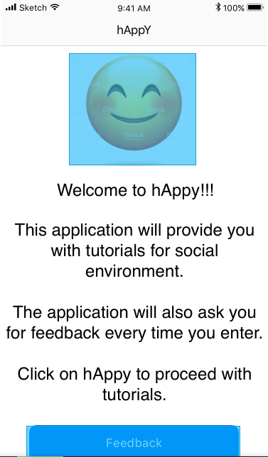

Emoji face = Button that takes you to the tutorial menu

Feedback button takes you directly to the Feedback page

Doesn’t have an Exit button in order to encourage the user to put feedback once entered the application.

No strict or classes used on this screen.

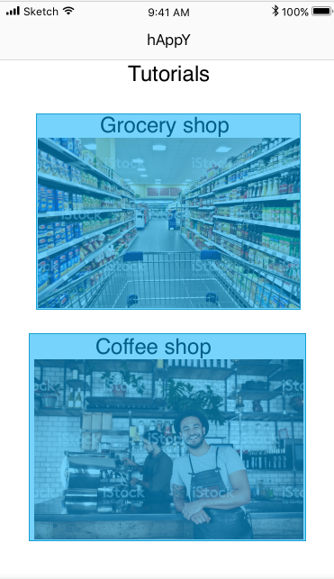

Each tutorial on the Tutorial menu represents a button that takes you to a specific tutorial page.

No struct or classes on this page.

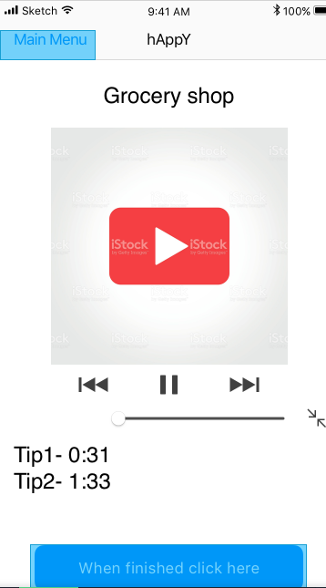

Grocery tutorial page.

Has a Main Menu button that takes you back to the First page.

Has another button on the bottom of the page that sends the user to the Feedback page.

Here a video will be displayed for a certain scenario. And there will be functionality to the video. Such as different points in time of the video where certain tips are displayed.

Will have neither structs nor classes.

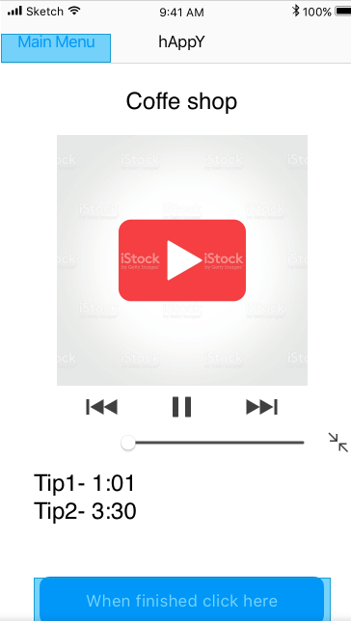

Coffee shop tutorial page.

Has a Main Menu button that takes you back to the First page.

Has another button on the bottom of the page that sends the user to the Feedback page.

Here a video will be displayed for a certain scenario. And there will be functionality to the video. Such as different points in time of the video where certain tips are displayed.

Will have neither structs nor classes.

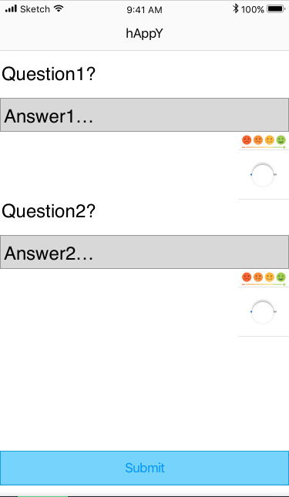

Feedback page.

There is a button on the bottom of the screen. When pressed the information filled by the user is sent to the researchers.

There are specific questions for different tutorials. Which will always be the same for the tutorials.

Contant = Questions = Strings

There is text box where the user will answer the question.

The box will use Strings the type of Strings will be used in a Struct, because every submission will be independent. The Answers/Strings can be stored in a Class type or a List. Depending how the researchers want the information to be stored.

The last key element to this page is the user mood regarding the question he/she answers.

We’ve added a slider with emoticons from a happy face on one side to sad face on the other. Depending on the current mood the user can drag the slider.

The slider will use Integer. The Integer will go from 0 to 100 points. 0 being sad and 100 being happy. Then the Integer is stored right next to the String, which will be the text answer of the user. It will user Struct as well. Because we want default placement every time the user accesses the page. Afterwards the String and Integer can be appended to Lists in order for the researchers to track the progress of the user.

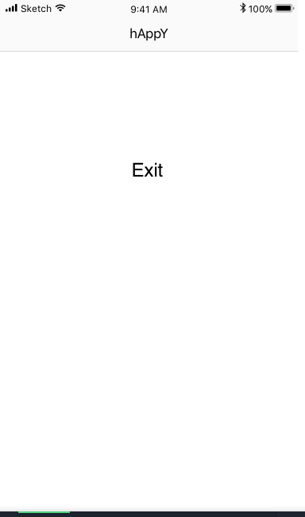

End screen.